**Smart Lighting CRM – Construction & Real Estate**

**Phase 2: Org Setup & Configuration**

After completing Phase 1: Problem Understanding & Industry Analysis, the next step is to configure the CRM environment to support smart streetlight operations. This phase focuses on preparing a secure, organized, and scalable system that allows operators, technicians, and facility managers to manage lighting assets, monitor energy usage, and schedule maintenance efficiently.

**1. Introduction**

The CRM platform is highly configurable, allowing organizations to customize workflows, security policies, and reporting dashboards. In this phase, the focus was on establishing the foundation for Smart Lighting CRM, ensuring users can access the system based on roles, follow proper security protocols, and have clear workflows for maintenance, monitoring, and reporting.

Key activities included: setting company settings, defining user roles and profiles, configuring access levels, setting up sandbox environments, and establishing initial deployment strategies.

**2. Objectives of this Phase**

* Configure the CRM according to the operational requirements of smart lighting management.
* Set up user roles, profiles, and permissions to ensure secure collaboration.
* Define Organization-Wide Defaults (OWD) and sharing rules for controlled data access.
* Prepare sandbox and testing environments for development and UAT.
* Implement secure login policies and access restrictions.

**3. Detailed Description of Contents**

**CRM Edition Selection**

* Analyzed available editions and selected a Developer/Enterprise Edition for building and testing.
* This allowed access to all key modules such as asset management, energy tracking, and maintenance workflows.

**Company Profile Setup**

* Defined organization information including name, address, time zone, fiscal year, and currency.
* Ensured regional settings aligned with project operations for accurate reporting and scheduling.
* This configuration supports operational consistency across multiple sites or construction projects.
* Created a Salesforce Developer Org using

https://developer.salesforce.com/signup.

* Verified the account, set the password, and gained access to the Salesforce Setup page.

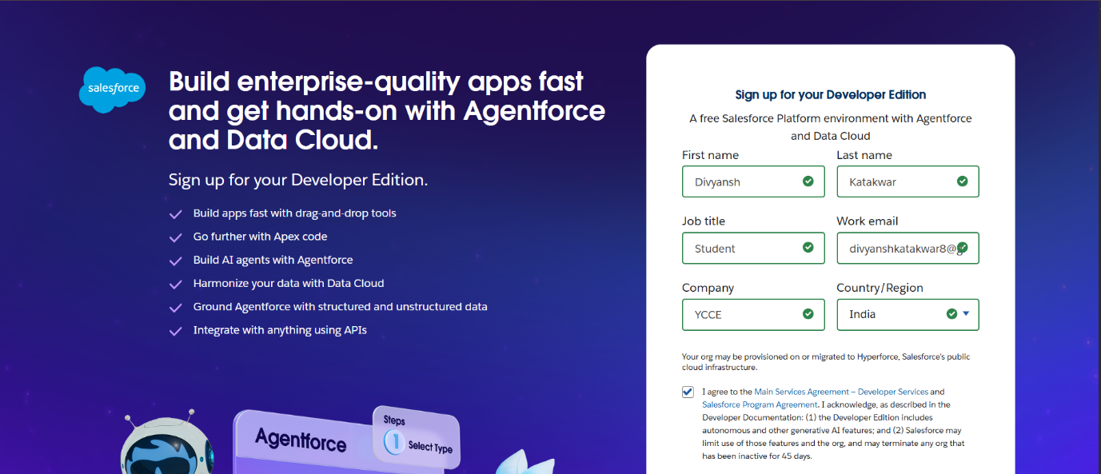

**Business Hours & Holidays**

* Configured working hours for facility operations (e.g., 9 AM – 6 PM, Monday – Saturday).
* Defined organization-wide holidays to ensure fault escalations and maintenance schedules respect non-working periods.

**Fiscal Year Settings**

* Aligned fiscal year with project financial cycles (e.g., April – March) for accurate energy cost and maintenance budget tracking.

**User Setup & Licenses**

* Created user types: Technicians, Operators, Facility Managers, and Admins.
* Assigned CRM licenses based on roles to ensure appropriate access:
  + Example: Technicians → limited access for logging faults and updates
  + Facility Managers → full access to dashboards and reports

**Profiles**

* Defined baseline permissions for users to control object-level and field-level access.
* Example: Technicians can update fault reports but cannot modify system settings.

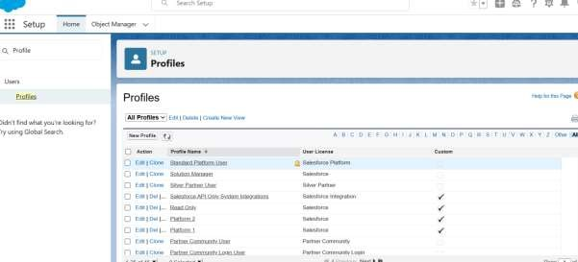

**Roles**

* Created a hierarchical structure to reflect reporting:  
  Technician → Operator → Facility Manager → Project Director
* This hierarchy ensures accurate data roll-ups for reporting and operational oversight.

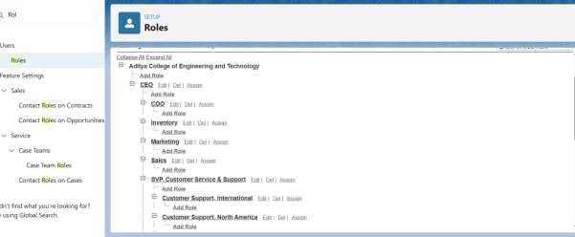

**Permission Sets**

* Implemented additional permissions for specialized tasks without altering base profiles.
* Example: Certain Operators given “Approve Emergency Maintenance” rights.

**Organization-Wide Defaults (OWD)**

* Established default access rules for data visibility:
  + Fault Reports: Private (assigned technicians only)
  + Streetlight Assets: Public Read-Only (all users can view)
  + Energy Reports: Controlled by parent asset

**Sharing Rules**

* Extended record access for collaboration between roles:
  + Example: Energy consumption reports shared with Project Director and Finance team.

**Login & Access Policies**

* Configured IP range restrictions and session timeout policies for security.
* Enabled admin login-as-user functionality for troubleshooting.

**Sandbox Environments**

* Created Developer Sandbox for isolated testing of customizations.
* Created Full Sandbox for User Acceptance Testing (UAT) with real data.
* Sandboxes ensured safe development without impacting production data.

**Deployment Strategy**

* Established migration techniques: Change Sets, CLI tools, or platform-specific deployment methods.
* Defined release workflow: Dev → QA → UAT → Production.
* This ensured a controlled and low-risk deployment process.

**4. Deliverables/Outcomes of Phase 2**

* Configured organization profile with company information, fiscal year, and operational settings.
* Defined business hours and holidays for workflows and escalations.
* Created user roles, profiles, and permission sets for secure access.
* Set OWD and sharing rules for controlled data visibility.
* Established login policies and secure access protocols.
* Created Developer and Full Sandbox environments.
* Prepared a structured deployment strategy for future phases.

**5. Conclusion**

Phase 2 established a robust and secure foundation for the Smart Lighting CRM. With properly configured roles, permissions, and sandboxes, the system now supports operational workflows for monitoring streetlights, logging maintenance, and tracking energy consumption.  
This setup prepares the project for Phase 3: Data Modeling & Relationships, where assets, fault reports, energy metrics, and user interactions will be structured and integrated for effective CRM operations.